

CSE541 Computer Vision

Weekly Report

Section-1

Submitted to faculty: Prof. Mehul Raval

Date of Submission: 16 March 2022

Student Details

| Roll No. | Name of the Student | Name of the Program |
| --- | --- | --- |
| AU1940315 | Shubham Jain | BTech-CSE |
| AU1940169 | Gaurav Bajaj | BTech-CSE |
| AU1940215 | Raj Chauhan | BTech-CSE |
| AU1940118 | Raj Gariwala | BTech-CSE |

**Tasks Performed in the week:**

* This week (due to midsemester exams) we couldn’t do much but we started with coding and constructing the Facenet Inception model.
* Our model implementation is based on Keras-OpenFace built by: <https://github.com/iwantooxxoox/Keras-OpenFace>
* We also discussed within the group about Transfer Learning and how to load a pre-trained model using this.

**The outcome of the tasks performed:**

* We got to know about the different layers involved in the Facenet inception model and what the structure of the Facenet inception model looks like. The below image precisely show the different layers of Facenet:

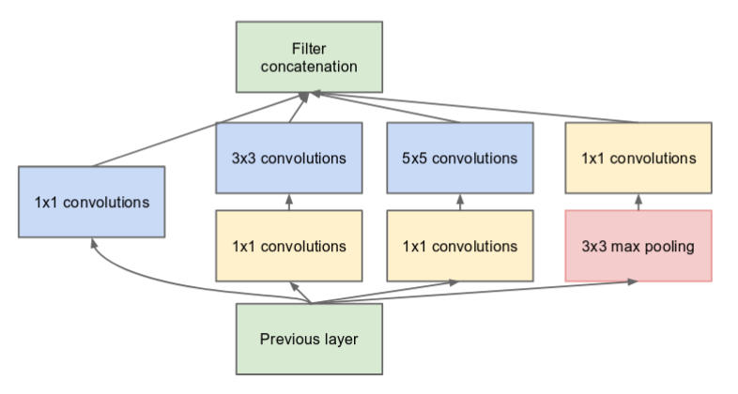

* Primarily, we also learned about how to build a model, how to build layers like Sequential, BatchNormalization, etc.

**Tasks to be performed in the upcoming week:**

* Will load weights in the pre-trained model using transfer learning.
* Create 128-dimensional embedding vectors for all the images data. We are planning to define a function that will take an image as an input and generate its embedding vector as output.
* If the time permits, we are also planning on implementing a function for recognizing face based on the theories and methods suggested in our referenced research paper.